गुरुर्ब्रह्मा गुरुर्विष्णुः गुरुर्देवो महेश्वरः । गुरुरेव परंब्रह्म तस्मै श्रीगुरवे नमः ॥

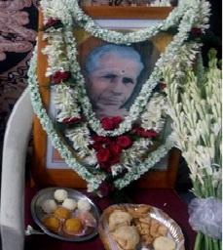

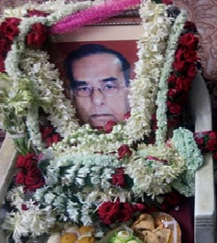
|| Late Prof. K.S. Krishnamuti || || Late Prof. P. Roychaudhary ||

ANNOUNCEMENT

This is to inform all JASA readers that a book on advanced concepts of KP Stellar Astrology is going to release shortly in Hindi language.

This book is in two volumes and run on around 300+ pages on about 150+ practical case studies of Natal and Horary Charts.

Book is written by Dr. Nirmal Kothari who is well known practicing Astrologer & Vastu-Expert. He has over 35+ years of practical experience in the fields of Astrology & Occult Sciences and posses many astrological titles/awards like Ph.D. in Astrology, Jyotish Visharad, Jyotish Acharya, Jyotish Gana Shiromani, Jyotish Shastri, Vastu Achrya, Vastu Shiromani, Vastu Srestham, Pyra-Vastu & Reiki-Pranik Healing Expert.

Dr. Kothari has developed a unique well tested and innovative method of KP Stellar Astrology popularly known as “Three & Half Step Theory (Back to Pavilion Method)”.

Readers are welcome to ask any query about this book to the below contacts numbers & e-mails.

- Dr. Nirmal Kothari : +91-98 30 089302 : kothari_nirmal@hotmail.com
- Mr. Navin Chitlangia : +91-98 30 580345 : astrologer.navin@yahoo.com

